Report by Arthi Ranganathan on the Crowd funding

**Table of contents** Page

1. Analysis based on the Raw Data - 2
2. Inference based on the Category - 4
3. Inference based on the Sub-Category - 5
4. Inference based on Pledge month, Goal - 6
5. Conclusion based on Statistical & Limitations - 7
6. **Analysis based on the Raw Data**

* There are 1000 companies considered for Crowd funding.
* The below graph tells us about total pledged amount vs Goal.

* Based on the percentage funded 565 Companies have contributed equal to/more than 100% of their Goal amount.
* Of these Williams-Jones topped the list with 2388% with Goal of 600 and total pledged amount 14033.
* 2 Companies Baldwin and Valdex Ltd did not make any contributions towards their pledged amount.
* Out of 1000 companies;565 are classified as successful outcome as they have pledged equal to/more than the Goal.
* 364 are classified as failed outcome as the they their pledge value is less than the Goal.
* 57 are classified as canceled.
* 14 are classified as still Live.

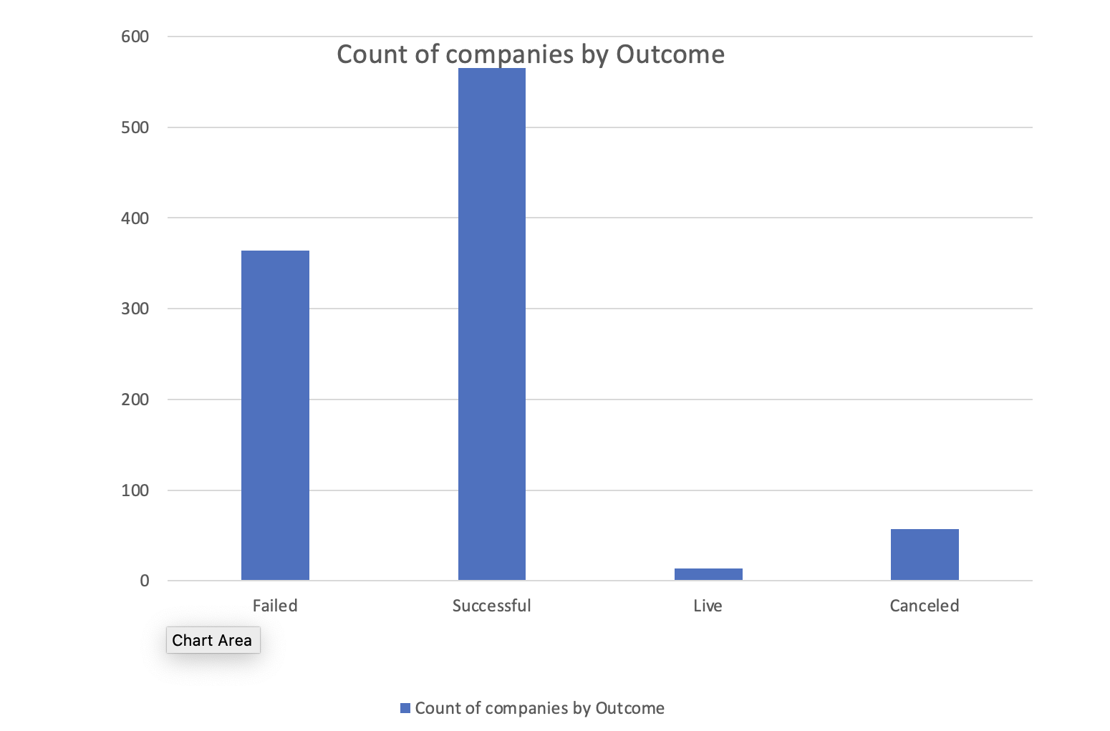

Contribution by Country

1. **Inference based on the Category**

* Contribution from category **theater** topped chart with highest number of successful outcomes with 187 followed by **Film & Video** with 102.
* Categories **theater, music, film & video** also topped charts the greatest number of failed outcomes 132,66 & 60 respectively.
* Majority of the contributions came from Theater(344), Film & Video (178) , Music(175).
* The remaining category had a total of 30% contributions.
* With Journalism contributing least among them.

**3.Inference based on the Sub-Category**

* Based on sub-category it is evident **theatre plays** tops the contribution with highest number of successful outcomes.
* It is also noted that the top pledge comparing with goal is from company (Garza-Bryant) which is under sub-category **theatre plays.**

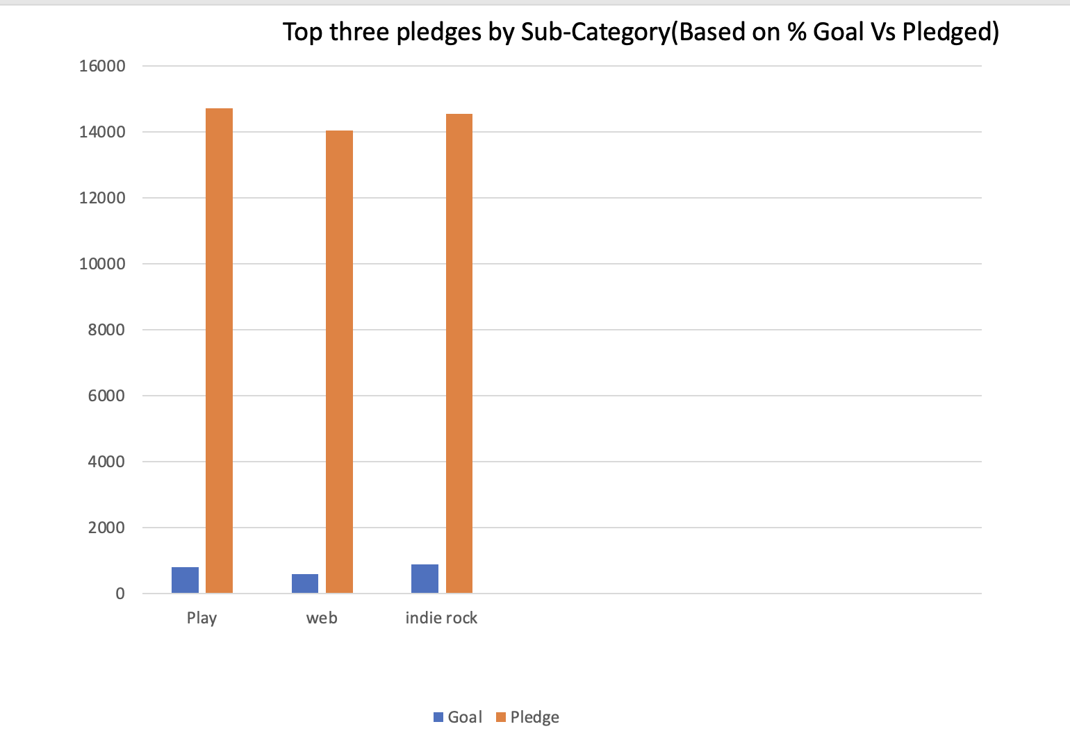

* The next top two successful outcomes are from sub-category **‘Music-Rock’** & ‘**film-video documentary’**.
* Its also noted that **theatre plays** topped number of failed outcomes with 132 contributions fell short of expectations.

1. **Inference based on Pledge month, Goal**

* Most number of campaign launches happened July and January.
* Looking at the graph there is a steep drop in number of successful campaigns from July to August month.
* The number of failed campaigns dropped during the month September and topped during January month.
* The number of failed campaigns remained under 10 through the year.

* Goals set greater than 50000 had more number of failed campaigns followed by range 5000-9999 which has 126 failed campaigns.
* Goals ranging 1000-9999 saw the most of successful outcomes.
* Goals ranging 15000-24999 & 30000-34999 saw 100 % successful outcomes.
* Also Goals ranging 5000-9999 has the most number of canceled outcomes.

1. **Conclusion on Statical Analysis & Limitations**

* Average number of successful backers were 851.
* Average number of un-successful backers were 585.
* Considering Mean is the right approach here;the successful backers stands at 201.
* Based on the Category Photography, Journalism, Food, Games had least contribution. These Categories should be concentrated during the next Crowd funding.
* Theater, Music, Film&Video have most number of failed campaigns. A detailed analysis needs to be done the root cause.
* Some of the attributes(Goal/Pledged) are missing Unit Values; Missing the unit values had limitations on preparing the presentations.
* Number of sample could have been more for better analysis of campaign.
* We Could not draw a much constructive conclusion on un-successful, failed campaigns as missing reasons behind them.

**Mean vs Median**

Based on Statistical Analysis Median much lower than Mean, this say that shape of the data is skewed to the right. In this case we would consider Median is better than Mean.

The mean average is calculated based on the full range. So, some of the high successful and unsuccessful backers contributing heavily to the average value. This may lead us to make incorrect assumptions. So, it makes more sense considering **Median** instead **Mean.**